**Events - Regular Expressions and JS Form**

**Objectives**

* Explain Events and Event Handler
* Describe regular expression
* Validate data in form

**Exercise 1** **(5 marks)**

Write a javascript program that displays the slideshow as shown below.

Open file page index.html (in CSS3) and add code below into between tag </nav> and <article>

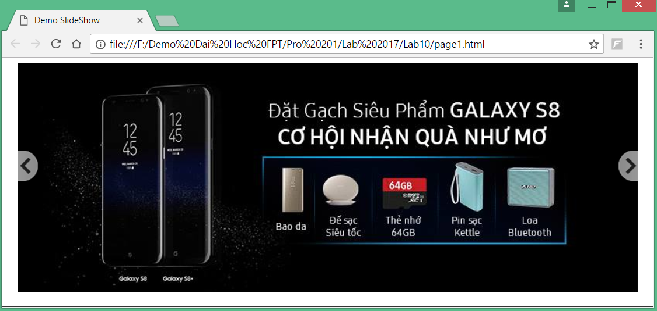

* **Code HTML**

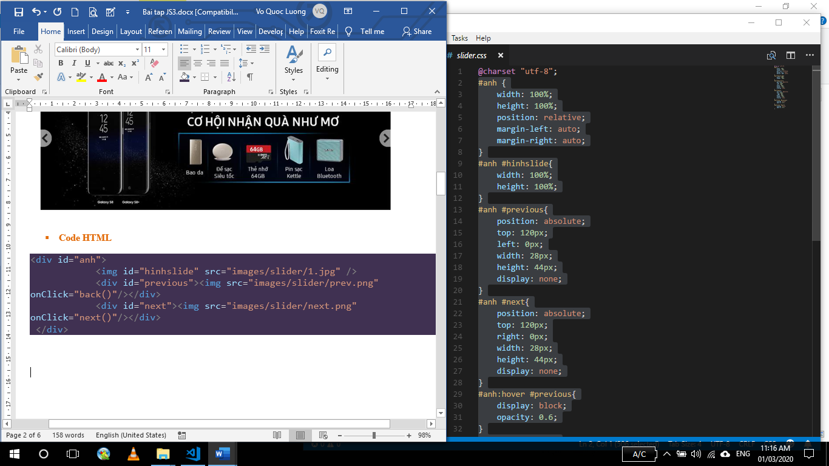

* **Code CSS**

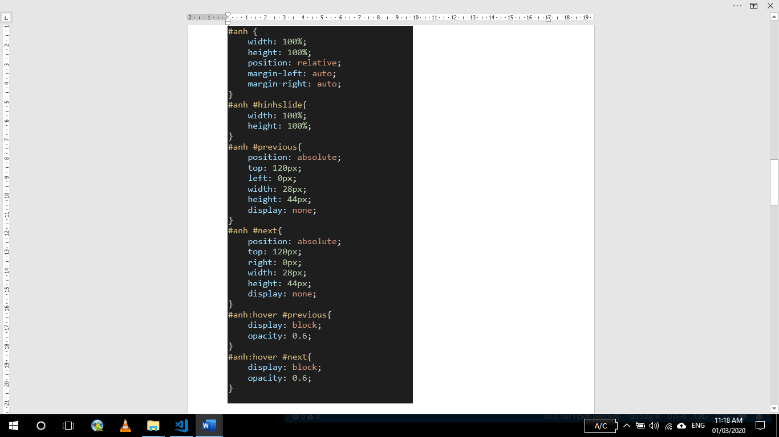

* **Code Javascript**

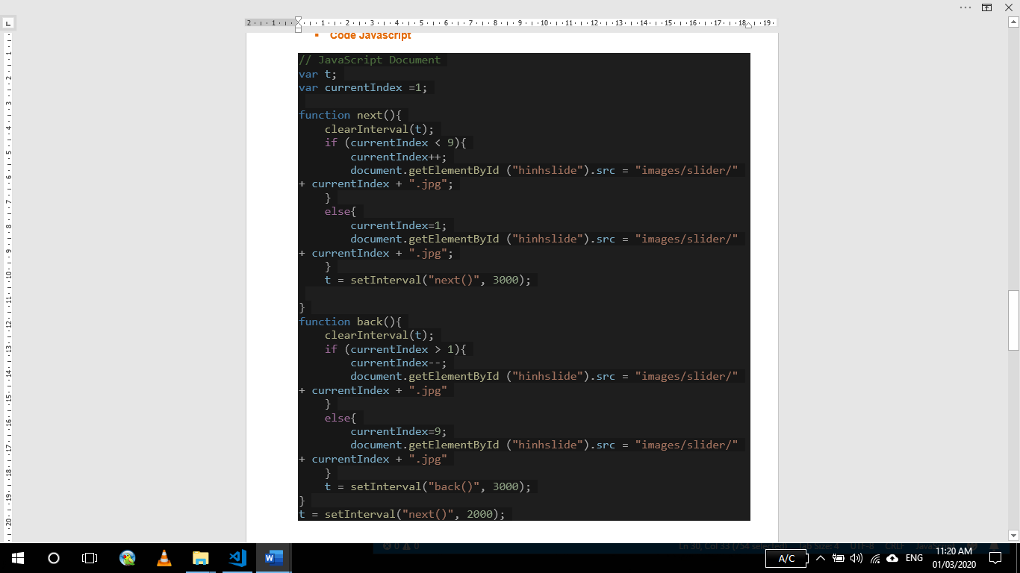

**Exercise 2 (5 marks)**

Using RegExp to check data in form and validate data by HTML5

